McKendree University
Fall Invitational

Stephen F. Forbes Lake, Salem, IL
Sunday, October 3, 2021
6:30 am – 2:30 pm
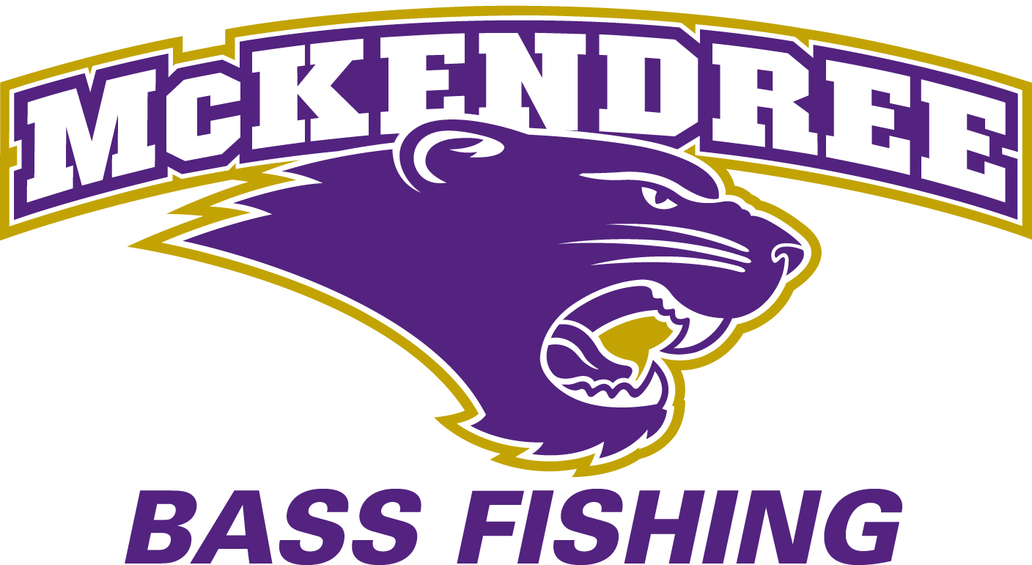
www.mckbearcats.com or www.mckendree.edu

(Any questions can be directed to Coach Jon Rinderer
via email at jarinderer@mckendree.edu or via phone at 618-541-2177.)

ENTRY FEE / PAY OUT: $70 Per Team (Includes $10/Boat Big Bass Pot)
(Save $10 - Only $60 Team (Including Big Bass Pot)
if you also fish our Saturday, October 2 Vandalia Tourney.)

*80% of entry fees will go to pay out for the tournament.
*20% of entry fees will go to the McKendree University Bass Team

Additional Prizes Drawing Items Will Include
Bass Pro Shop Gift Cards

REGISTRATION:
*Online Registration: Anglers can register online at www.collegiatebasschampionship.com. Follow the
registration tab, and provide all required information to register. If you register online, please fill out the
entry form, and bring it with you to the pre tournament meeting. Only cash will be accepted as payment
when paying the morning of the tournament. Fish our Vandalia Tournament on Sat, Oct 2 (the day before) and save $10.

*Phone Registration: Anglers can register by calling 618-541-2177 at least one week before the tournament
date. Only cash will be accepted as payment when paying the morning of the tournament.

*Tournament Morning Registration: Anglers can register from 5:30 am – 6:00 am on tournament morning.
Only cash will be accepted as payment when paying the morning of the tournament.

Each School May Bring An Unlimited Number Of Teams

The McKendree University Fall Invitational is a
Bass Pro Shops ACA School Of The Year Event.

TOURNAMENT EVENTS
Pre-Tournament Practice
*There is no off-limits fishing period leading up to the event. Competitors will be allowed to practice any time leading up to the event.

*All tournament rules do apply during pre fishing days.

Pre-Tournament Meeting
*There will be a pre-tournament meeting at 6:15 am the morning of the tournament at the East Launch Ramp (Near the Dam)

OFFICIAL TOURNAMENT RULES
*Participation in the McKendree University Fall Invitational constitutes each contestant’s understanding of, full and unconditional agreement to, and acceptance of these Official Rules. Failure to read these rules is no excuse. Contestants must obey all State, Federal, Dept. of Conservation, and local fishing and safety laws and regulations. The Tournament Director reserves the right to disqualify any contestant that is determined to be in violation of any term contained in these Official Rules. These rules will be interpreted by the Tournament Director, and all decisions are final. Protests or complaints must be filed in writing before the weigh-in scale closes. The situation will be given consideration and ruled on by the Tournament Director.

Participation/Eligibility
*Participation is open to college students who are enrolled full time in an accredited community college, college, or university and are members in good standing of that college or universityʼs institutionally recognized fishing club/team. Only students who are enrolled as a full-time undergraduate student are permitted to fish. Proof of enrollment (ID Card) may be requested.

*There is no limit to the number of boats from each club/team that are allowed to fish this tournament. (Only two competitors will be allowed per boat.)

*All contestants must have in their possession a valid Illinois fishing license.

Tournament Hours
*The tournament hours are from 6:30 am - 2:30 pm.

Take-Off
*Take-off will be held at the East Launch Ramp (Near the Dam).

*Take-off positions will be drawn at the pre tournament meeting.

*Basic rules and tournament hours will be discussed 15 minutes prior to take off.

*The take-off site area will be the official check-out and check-in area.

*Live-wells and kill switches will be inspected during take-off.

Weigh-In
*Weigh in will be held at the East Launch Ramp (Near the Dam) and will begin at the end of the tournament hours. No fish will be weighed until that time.
*Contestants must be at the scale with fish within a 1/2 hour after check-in.

*Bringing more than 5 fish to the scale will result in disqualification.

Tackle and Equipment
*Only artificial lures or baits may be used.

*All bass must be caught alive on a rod and reel during the tournament hours from a boat in a sporting manner. No Trolling.

*Only one rod per angler may be used at a time. You must retrieve your previous cast before making another.

Boats and Motors
*Anglers must provide their own boats. No volunteer boaters will be provided.

*Boats must be 15 feet or longer, with properly working aerated live-wells and kill switch.

*No overpowered boats allowed.

*All boats must meet B.I.A., U.S. Coast Guard, and State Water Patrol regulations.

Safety
*All boat operators must have at least the state minimum liability insurance coverage on the boat.

*Safe boating and fishing practices must be observed at all times. Contestants must observe “no wake” areas including bridges and other areas identified by the Tournament Director.

*Each contestant is required to wear a fastened, U.S. Coast Guard approved, personal flotation device at any time the combustion motor is running. All boats must be equipped with an emergency ignition shut off device that must be securely attached to the driverʼs body whenever the combustion engine is in operation.

*In the event that severe weather occurs, anglers will be notified via cell phone/text to stop fishing and to get off of the water.

Permitted Fishing Locations
*Contestants may fish anywhere on tournament waters available to the public and accessible by boat, except any areas designated as “Off-Limits”, “No Fishing”, “No Boats”, “Boats Keep Out”, etc. by the Corp of Engineers, or other local, state or federal officials. Contestants are prohibited from casting into these areas or having their boat in these areas at any time. (If any additional areas exist at the time of the tournament, they will be discussed at the pretournament meeting.)

*At no time may a contestant leave the boat to land a fish or make the boat more accessible to fishing waters. The only time a contestant is allowed to leave the boat during tournament hours is to free the boat from an obstruction or in the event that personal safety is at risk if he/she stays in the boat. Please call the tournament director in this instance.

*The tournament boat must remain in the tournament waters during tournament day.

*Contestants must leave and return to the official checkpoint by boat.

*No additional boats containing coaches, anglers, family, or friends from a competitor’s school can be in the water.
*In the event of equipment failure or emergency, there will be only two permitted methods of returning to the official checkpoint: By both team members remaining in their boat and being towed by water, or by one or both team members entering the boat of another tournament contestant. Under these two conditions the teams catch may be counted without a penalty (except for any late penalties, fish care penalties or other penalties pertaining to other tournament rules).

*No tournament boat may be loaded on the trailer before weigh-in except with the permission of the Tournament Director.

Sportsmanship
*Each member of each team is representing themselves, their university, and this tournament. Therefore, each contestant is expected to follow high standards of sportsmanship and courtesy and maintain a professional demeanor throughout the entire event.

*Consumption and/or possession of any alcoholic beverages, or any kind of mind altering substance, during the entire event on or off the water (registration, the pre-tournament meeting, during tournament hours extending through the weigh-in, etc...) are strictly prohibited.

*No littering of the lake or banks; be sure to dispose of all trash at the check in point.

*No hole sitting or holding a fishing spot for another fishermen or contestant.

*No fishing within 50 yards of an anchored boat.

*No soliciting of a guide within one month of an event on that body of water.

*No receiving fishing advice or “spots” from anyone during tournament hours. The use of mobile communication devices, including, but not limited to cell phones, marine radios, two-way radios, CBʼs, etc., during tournament hours is strictly prohibited except in an emergency (severe weather, etc.).

Scoring
*Scoring will be determined by the weight of each teamʼs catch, including any penalty assessments.

*Only Largemouth and/or Smallmouth bass are accepted species.

*Fish must have a minimum length of 14 inches. Fish will be measured on a Golden Rule bump board, with mouth closed and tail fanned to the longest position.

*The limit will be five (5) bass per team. Teams may not have more than five (5) bass in the livewell
at any time unless actively culling. Culling must be done immediately.

Ties
*A tie for the total weight will be decided by the biggest bass weighed.

*If a tie still remains, the tie will be decided by number of fish.

Penalties
*LATE PENALTY: All boats must check-in. Any boat weighing in fish that does not check-in will be disqualified. Any competitor not back at the official checkpoint by the designated end time will be penalized 1 lb per minute. After 15 minutes that boat will be disqualified, regardless of excuse. Late is late. The check-in area will be the same area as the take-off area.

*SHORT FISH: Any competitor weighing in a fish shorter than 14 inches will be penalized 1 pound and the weight of the fish for each short fish presented. (Courtesy bumps will be available for anglers to do on their own, and they must be asked for and completed prior to having the fish bumped by the weigh master.)

*DEAD FISH: Any dead bass presented for weigh-in will result in a penalty of 1 pound deducted from the total catch weight. Only 2 dead fish are allowed per boat.

*CHEATING: If anyone is caught cheating by accepting fish from someone else, tying up fish, weighting or altering fish in any way, or by any other means, he/she will be disqualified. The teamʼs school will also be notified.

*BREAKING OF RULES: Anyone who breaks a rule is subject to disqualification at the Tournament Directorʼs sole discretion.

*CHALLENGE RULE: Short or dead fish may be challenged. Weigh-in will be stopped and every effort will be made to determine if the fish is short or dead.

*PROTESTS: A protest or complaint may be filed in writing before the weigh-in scale closes. The situation will be given consideration and ruled on by the Tournament Director. All decisions will be final.

www.mckbearcats.com or www.mckendree.edu

